Lab: Automated Testing
Lab for the DevOps for Developers module @ SoftUni

We are given a simple JS app that lets the user add tasks, mark them as completed, delete them and filter them according to their status.
We should use Playwright and write some code to test the UI of this app.

Bug Tracking Tools
You can check-out the links below and take a look at how bugs are tracked in real projects:
- https://github.com/twbs/bootstrap/issues
- https://github.com/twbs/bootstrap/issues/31392
- https://daosio.atlassian.net/jira/software/c/projects/CART/issues

Integration Testing
Open Visual Studio and load the TownsApplication from the resources to inspect it. It is a simple application which let's you input data about towns and validate them in the process.
The architecture of the application can be defined as a basic MVC-like structure, although it is a console application:
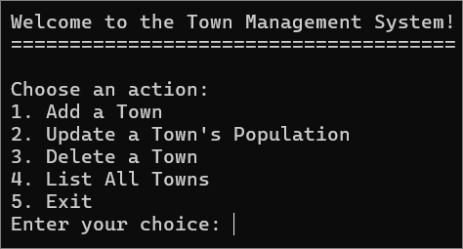
The application has a controller layer – TownController which is responsible for the business logic of the application and handling the CRUD operations. It has four methods:
- AddTown – add a town
- UpdateTown – update a town's population
- DeleteTown – delete a town by id
- ListTowns – list all of the input towns.
The data access layer is represented by the TownDbContext. It also manages the interaction with the in-memory database. The table of towns in the database is represented by the DbSet<Town> property. The OnConfiguring method ensures that the context uses in-memory database.
The domain model for storing towns is represented by the Town data model.
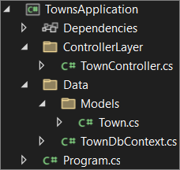
How does the application work? The TownController calls methods that interact with the TownDbContext.
 | For the purpose of this demo, the TownDbContext uses an in-memory database.  Remember that you won't be working with apps that have in-memory database in the real world. It is considered bad practice using in-memory databases in production environments and for performance testing.  The common uses for in-memory database are for unit and integration testing (but for the tests themselves, not for the application that is being tested).
And how does the integration testing work on this app? As you can see, each test uses a fresh in-memory database to ensure that tests are independent. This is done by the ResetDatabase method in the controller.
After that, we have tests that are executed on these newly initialized databases.
You can see the whole process for each test described in the diagram below:
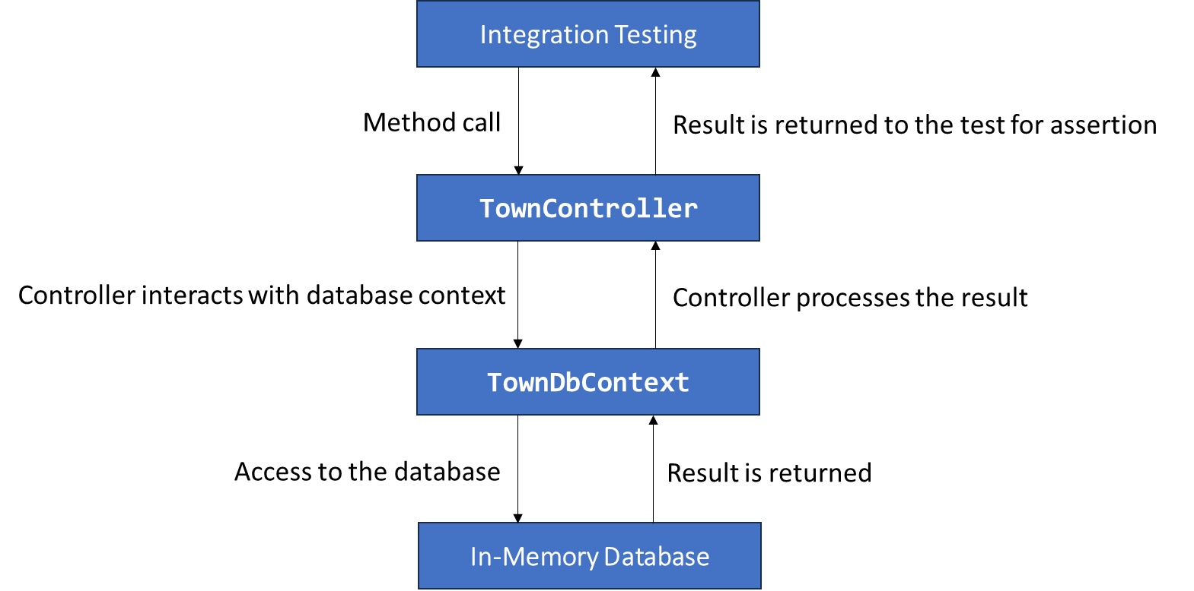
Finally, let's see how to execute the tests. Usually, to run xUnit tests, you need the packages described below:
xunit
xunit.runner.visualstudio
You can either download them using the built-in NuGet Package Manager from Visual Studio or use the CLI to download and install them.
For you, as a developer, it is a must-know how to use CLIs, so open the Package Manager Console in Visual Studio, chose the TownApplication.IntegrationTests project and use the following commands to download and install the required packages:
Install-Package xunit
Install-Package xunit.runner.visualstudio
We will also be using the CLI to run the tests using the command below:
dotnet test
Now you know how to run integration tests written with xUnit on a C# application. Don't worry, in the next session, we will see more examples.

Swagger
In the resources, you have a BooksAPI application, written with C#.
This is a simple REST API for displaying, creating, editing and deleting products. The Swagger tool is used to document the API and try it out directly from the browser.
The BooksApi application follows a layered architecture that separates concerns into distinct projects, which is a common and best practice in large-scale applications.
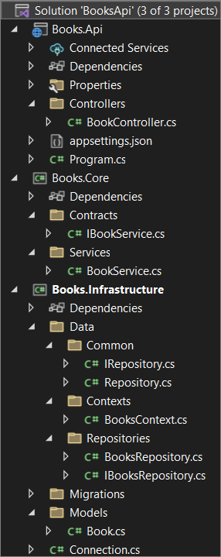
The solution is composed of three distinct projects:
- Books.Api
- Books.Core
- Books.Infrastructure

Books.Api (Presentation Layer)
This project represents the API layer of the application.
The BookController in it exposes HTTP API endpoints that clients (such as web or mobile apps) interact with. The controller interacts with the underlying services to handle requests related to books.
In this layer there is also the entry point of the API – Program.cs
This layer depends on Books.Core to handle business logic and Books.Infrastructure for data access.

Books.Core (Business Logic Layer)
This layer is responsible for handling the business rules, data validation, and operations that do not directly involve database access. Here we have the contracts and the services.
Contracts are represented by interfaces that define the business logic operations, which are related to the books. In other word, these are the abstract definitions of the methods for CRUD operations.
Services implement the business logic defined in the interfaces. In this case, the services interact with the repositories to handle operations that manage books in the database. It enforces business rules and validations before data is passed to the repository layer for persistence.

Books.Infrastructure (Data Access Layer)
This project contains the data access logic, interacting directly with the database and models.

Swagger Integration
We have Swagger integrated into the Books.Api project, allowing developers and users to explore and interact with the API via a user-friendly web interface.
Swagger automatically generates API documentation based on the controller and model definitions, and it provides an interactive interface where users can execute API operations (GET, POST, PUT, DELETE) directly from the browser.
You can run the app and explore the API interface in the browser.
Now that you have acknowledged yourself with the architecture of this API application, you will be able to perform some testing using it in the next session.

Web UI Testing
In the resources, there is a To-Do app. This is a simple JS app that lets the user add tasks, mark them as completed, delete them and filter them according to their status. It has some Playwright tests written. In order for you to be able to run them, you need to open Visual Studio Code and install Playwright using this command:
npm install
npm install @playwright/test
npx playwright install
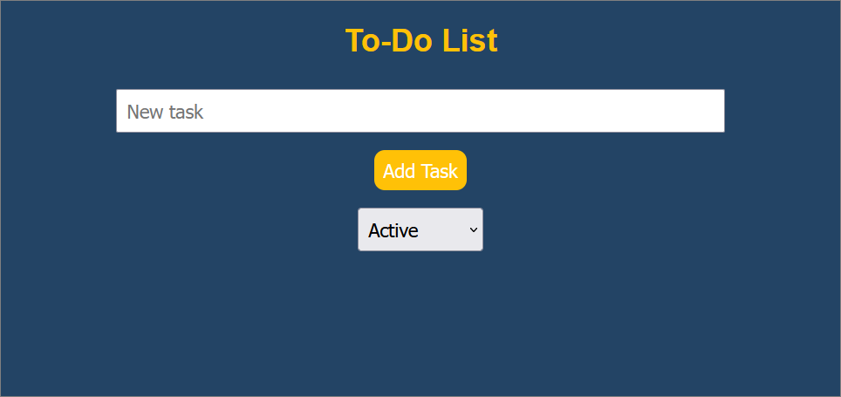

npm install @playwright/test
This command installs Playwright's test package (@playwright/test) into your project using npm. The package provides utilities for writing and running tests, specifically built for Playwright. It adds Playwright as a dependency to our project, enabling us to write tests for browser automation.

npx playwright install
This command installs the necessary browser binaries (such as Chromium, Firefox, and WebKit) for Playwright. As you know, Playwright automates browser actions, and this command ensures that the required browsers are downloaded and available locally for testing.
Now, let's start the server using
npm start
Finally, we can run the tests, using this command:
npx playwright test
We should see that all of the tests pass:
